Amended Senior Fencing Rules
Procedure
At the Glamorgan YFC Final the team will be required to erect a stock proof boundary fence using the materials provided, as illustrated in the diagram.
The team will be required to erect a 15m stock proof boundary fence using the materials provided (as illustrated in the diagram).
The fence shall be in a straight line for 15 metres.
Total height to top wire of fence 1.15m (45”).
The intermediate posts shall be at equal spacing.
It shall be constructed of post and netting with 1 strand of barbed wire above the netting.
The netting shall be set 100mm (4”) above the ground approximately.
There shall be 1 strand of barbed wire above the netting, set at 100mm (4” approximately) above the top of the netting.
Netting and wire shall be secured to the end strainers using a recognised knot.
At one end of the fence there will be a box strainer assembly using a horizontal strut and diagonal brace wire as per diagram.
The box strainer shall be made with 1 x 2.4m (8’) strainer and 1 x 1.65m (5’6”) post, with a 2.4m (8’) horizontal brace, with plain wire.
The horizontal brace shall be morticed into the strainers on both ends.
At the other end of the fence there should be a strainer with a diagonal strut. The assembly shall be made using a 2.4m (8’) strainer and 2.4m (8’) angled strut, with the strut secured using a horizontal thrust block.
The strut must have a thrust plate at the end to prevent movement. Struts not to be left open (ground filled). The strut is to be morticed into the strainer at 450mm (18”) to the top of the strut – ie, between the 4th and 5th wire on the net.
Wire joints - All joints to be made during the competition.
No joining aids will be permitted. A join in the netting should be made by hand approximately in the middle of the length. A join in the barbed wire approximately in the middle of the length must also be completed.
The team are required to prepare a written risk assessment/method statement, which is to be handed to the Chief Steward on the day of the competition - prior to the competition start. Failure to provide a written risk assessment/method statement or failure to comply with it; or working unsafely, will result in immediate disqualification.
Please see an example of a Fence Erecting Risk Assessment Template below. This may be used and completed as teams wish (Risk 1 already entered as an example). Teams are welcome to complete their own risk assessment.
List of items Provided by Glamorgan YFC
2 x 2.25m (7’6’’) round pointed posts, 125-150mm (5”-6”) diameter (strainers)
2 x 2.4m (8’) round posts, 75-100mm (3”-4”) diameter (horizontal strut, diagonal strut and thrust plate)
5 x 1.65m (5’6”) round pointed posts, 75-100mm (3”-4”) diameter (intermediates) 1 x chock (thrust plate) 300mm x 125mm x 75mm (12 x 5 x 3 inches)

Each team to supply:
20m x mild steel stock netting C8/80/22 20m x barbed wire.
10m x plain wire
50 x nails 5mm x 110mm (approx 1kg) (4 ½ inch nails)
Staples Only hand tools will be allowed and the teams themselves must provide these. No powered tools or chain saws are allowed. All tools and equipment used must be fit for purpose and be in good condition, well maintained and safely operated by members of the team at all times. Judges/stewards hold the power to stop the use of tool/piece of equipment if, in their view, it is not safe to use or is being handled/used in an unsafe manner.
Competitors are not allowed to shorten any of the vertical posts. The Judge reserves the right to inspect any strut following completion of the task. All teams are required to dismantle their fence after the Presentation of Awards (the thrust plate and must be out of the ground). Any team not complying with this ruling will be disqualified. Cleaning the ground –Teams are required to clear away all debris and any off-cuts of wire etc must not be put down the postholes. Receptacles will be provided for this purpose. Soil will be available to make the ground good.
TIMING 1 hour 30 minutes will be allowed for the completion of the task. To note that once the time of 1 hour 30 minutes has been reached, teams will be asked to stop, and the fence will be judged as seen. Please note that the tidying of tools and equipment away will be included in the time to complete the task.

MARCIO / SCALE OF MARKS
Fixing end posts, strainer post, diagonal strut & box strainer 30
Intermediate posts 10
Overall neatness 20
Fixing and tensioning of netting & barbed wire 25
Joint in netting and barbed wire 10
Written Risk Assessment 5
TOTAL 100
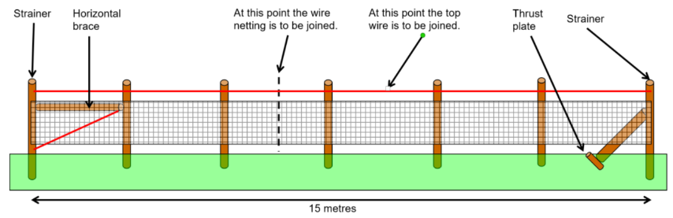

Nid yw’r darlun hwn wrth raddfa a chynnig enghraifft yw’r unig fwriad. Rhaid i’r cystadleuwyr benderfynu faint o le sydd rhwng y polion
Diagram is not to scale and is for illustrative purposes only. All spacing’s to be determined by the competitors

