1st Field day
County Competition- Mount Pleasant Farm, Stormy Down, Glamorgan, CF33 4RR
Saturday 30th September 2023

Junior Fencing
ELIGIBILITY
A team shall consist of three members, two members shall be 21 years of age or under on the 1st September, 2023 and one member shall be 18 years of age or under on the 1st September 2023 and full members of a YFC Club based in Wales and affiliated to either Wales YFC or NFYFC.
Competitors will be required to show their membership cards.
Failure to produce a valid membership card (with photo) will result in a £5 penalty charge.

HEALTH & SAFETY – ESSENTIAL READING / ACTION FOR ALL COMPETITIORS
It is essential that all competitors read the Health and Safety Executive’s guidance paper concerning fencing and note is taken of the safe working practices and protective clothing equipment that is recommended. The Health & Safety Executive guidance paper ‘Fencing’ (AFAG104) can be downloaded from the NFYFC or Wales YFC website.

PROCEDURE
The team will be required to erect a stock proof boundary fence, using the materials provided (as illustrated in the diagram).

The fence shall be 12 meters in a straight line, constructed of post and netting with 1 strand of barbed wire above the netting and 1 strand of barbed wire below the netting.

At both ends of the fence there must be a strainer with a diagonal strut (strut secured using a thrust plate).

A join in the netting must be made by hand (no gripples/crimps) where shown on the diagram.

The barbed wire must be tensioned and tied with a knot at both ends.

Posts may be driven into the ground, where required. Water may be used down the holes (teams to provide this themselves).

Only hand tools will be allowed and the teams themselves must provide these. No powered tools or chain saws are allowed.

All tools and equipment used must be fit for purpose and be in good condition, well maintained and safely operated by members of the team at all times. Judges hold the power to stop the use of tool/piece of equipment if, in their view, it is not safe to use or is being handled/used in an unsafe manner.

Competitors are not allowed to shorten any of the vertical posts.

The Judge reserves the right to inspect any strut following completion of the task.

All teams are required to dismantle their fence after the Presentation of Awards. Any team not complying with this ruling will be disqualified.

Cleaning the ground –Teams are required to clear away all debris and any off-cuts of wire etc. must not be put down the postholes. Receptacles will be provided for this purpose. Soil will be available to make the ground good.
List of Items provided by Glamorgan YFC:

2 x Strainers: 2.2m, 125mm – 150mm diameter round posts with points(7ft, 5” – 6”)

2 x Diagonal Struts: From 2.4m x 100mm diameter round post (8ft, 3” – 4”)

3 x Intermediate posts: 1.7m x 100mm diameter round posts (5ft 6”, 3 – 4”)

2 x Thrust Plates: 9” x 3” x 4” (wood)

Each team to provide-

15m x mild steel stock netting C8/80/15
30m x mild steel barbed wire

6 x 5” nails
Staples

TIMING
One hour 45 minutes will be allowed for completion of the task.

Time penalties
Teams will be encouraged to complete the task but will lose one (1) point for every minute or part thereof over the allocated time. At the Wales YFC final teams will be asked to stop 30 minutes after the allocated time. i.e. at 3 hours.
Please note that the tidying of tools and equipment away will be included in the time to complete the task.

The judging will take place straight after stated time above.
SCALE OF MARKS

Straining posts & Strut fixing | 50
Fixing and tensioning of netting | 50
Fixing and tensioning of barbed wire | 25
Join in netting | 20
Intermediate post | 25
Overall neatness of finished job | 30
TOTAL | 200
The Judges decision is final.

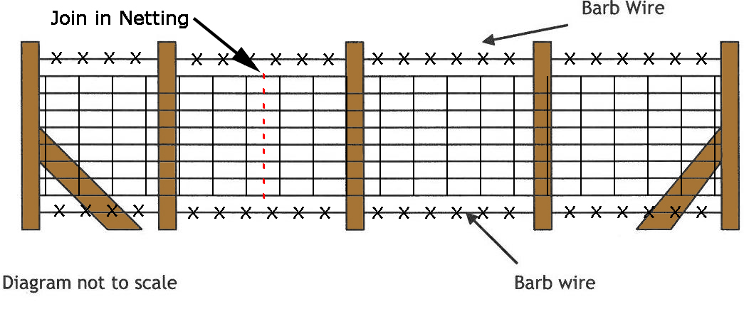

Senior Fencing
ELIGIBILITY
A team shall consist of three members 28 years of age or under on 1st September, 2023 and full members of a YFC Club based in Wales and affiliated to either Wales YFC or NFYFC. Competitors will be required to show their membership cards.

Failure to produce a valid membership card (with photo) will result in a £5 penalty charge.

ACTION FOR ALL COMPETITIORS
It is essential that all competitors read the Health and Safety Executive’s guidance paper concerning fencing and note is taken of the safe working practices and protective clothing equipment that is recommended. The Health & Safety Executive guidance paper ‘Fencing’ (AFAG104) can be downloaded from the NFYFC or Wales YFC website.

PROCEDURE
For each round of the competition, the two end strainer posts will be put into the ground prior to the competition by the organisers. This to be discussed at County level before the competition.
The team will be required to erect a 22m stock proof boundary fence using the materials provided (as illustrated in the diagram).

Total height to top of fence 45 inches.
The intermediate posts shall be at equal spacing.

From the start point, the fence shall be in a straight line for 12m before turning approximately 30° to the right and continuing for a further 10m.

It shall be constructed of post and netting with 2 strands of high tensile steel wire above the netting.

One strand of high tensile wire (ground wire) to be placed 2” above ground level.

The netting shall be set 2” above the ground wire.

There shall be 2 strands of high tensile plain wire above the netting, set at 2” & 5” above the top of the netting – ie, 2” between the netting and lower wire, then 3” between the 2 wires.

Netting shall be secured to the end strainers using a recognised knot.
At one end of the fence there will be a box strainer assembly using a horizontal strut and diagonal brace wire.
The box strainer shall be made with 2 x 2.4m (8’) strainers and a 2.4m (8’) horizontal brace, with 2.5 HT plain wire.
The horizontal brace shall be morticed into the strainers on both ends.
At the other end, the fence will be secured with a strainer assembly:
- The assembly shall be made using a 2.4m (8’) strainer and 2.4m (8’) angled strut, with the strut secured using a horizontal thrust block.

- The thrust block shall be dug 200m (8”) below ground level and be left open for judges inspection.

- 2 horizontal blocks on the bottom of the strainer.

- The strut is to be morticed into the strainer at 450mm (18”) to the top of the strut – ie, between the 4th and 5th wire on the net.

- Where the fence turns 30°, the turning post shall be a straining post without struts.

- A hand tied joint will be required in the netting and a hand tied joint in the top line wire; towards the centre of the fence (no joining aids will be permitted).

- A join in the netting must be made by hand where indicated on the diagram.

The team are required to prepare a written risk assessment/method statement, which is to be handed to the Chief Steward on the day of the competition - prior to the competition start. Failure to provide a written risk assessment/method statement or failure to comply with it; or working unsafely, will result in immediate disqualification. Please see an example of a Fence Erecting Risk Assessment Template below. This may be used and completed as teams wish (Risk 1 already entered as an example). Teams are welcome to complete their own risk assessment.

List of Items provided by Glamorgan YFC:
(see list of materials below).

4 x Strainers - 2.4m x 150mm – 175mm diameter round posts (8ft, 6”– 7” round)
1 x Angled Strut - From 2.4m x 100mm – 125mm diameter round post (8ft, 4”– 5” round)
1 x Horizontal Strut - From 2.4m x 100mm – 125mm diameter round post (8ft, 4”– 5” round)
2 x Intermediate posts - 1.65m x 75mm - 100mm diameter round posts (5ft 6”, 3”– 4” round)
Thrust Plate and Cross Members – From 1.8m x 150mm x 75mm (6ft x 6”x 3” square)

Each Team to supply:
25m x High Tensile stock netting HT8/80/15
75m x High Tensile plain wire 2.5mm gauge
6” nails
Staples

Only hand tools will be allowed and the teams themselves must provide these. No powered tools or chain saws are allowed.
All tools and equipment used must be fit for purpose and be in good condition, well maintained and safely operated by members of the team at all times. Judges/stewards hold the power to stop the use of

tool/piece of equipment if, in their view, it is not safe to use or is being handled/used in an unsafe manner.

Competitors are not allowed to shorten any of the vertical posts.
The Judge reserves the right to inspect any strut following completion of the task.

All teams are required to dismantle their fence after the Presentation of Awards (the thrust plate and any blocks/cross members must be out of the ground). Any team not complying with this ruling will be disqualified.

Cleaning the ground –Teams are required to clear away all debris and any off-cuts of wire etc must not be put down the postholes. Receptacles will be provided for this purpose. Soil will be available to make the ground good.
2 hours 30 minutes will be allowed for the completion of the task.

Time penalties
Teams will be encouraged to complete the task but will lose one (1) point for every minute or part thereof over the allocated time. At the Wales YFC final teams will be asked to stop 30 minutes after the allocated time. i.e. at 3 hours.
Please note that the tidying of tools and equipment away will be included in the time to complete the task.

/ SCALE OF MARKS

Box Strainer Assembly 50
High Tensile Fencing- strainer Assembly 50
Turning Post 20
Intermediate Post 20
Fixing & Tensioning of Netting 40
Fixing & Tensioning of Plain Wire 30
Joining in Netting 30
Overall Neatness of Finished Job (including
surrounding area) 40
Written Rist Assessment 20
Total 300

The Judges decision is final.

Diagram is not to scale and is for illustrative purposes only
All spacing’s to be determined by the competitors

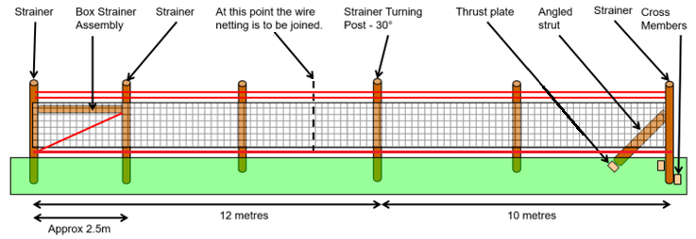

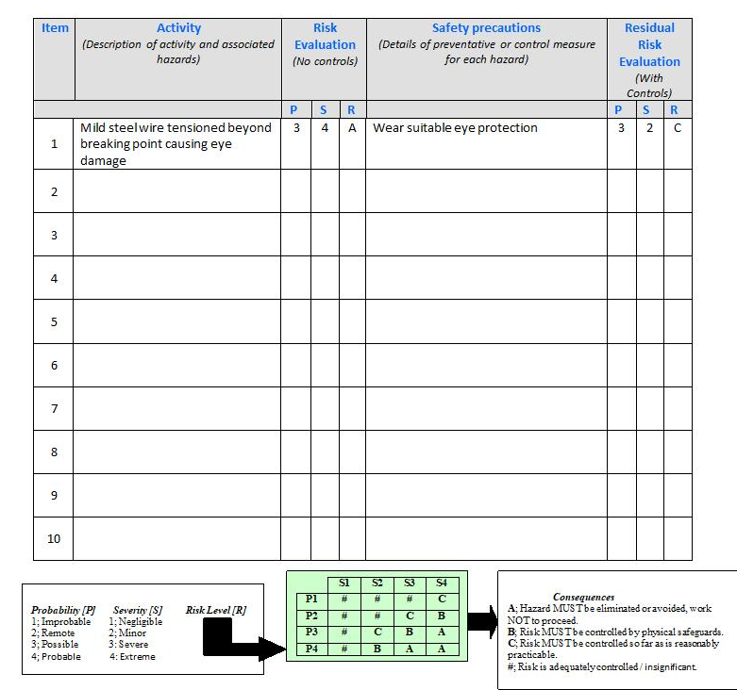

Sheep Dog Trials
ELIGIBILITY
One competitor whom must be 28 years of age or under on 1st September 2023 and full members of a YFC Club based in Wales and affiliated to either Wales YFC or NFYFC.
Competitors will be required to show their membership cards.

Failure to produce a valid membership card (with photo) will result in a £5 penalty charge.

PROCEDURE
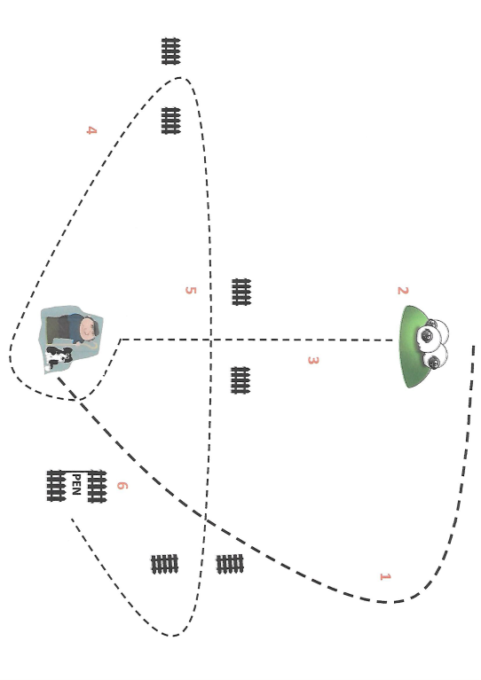
The course is intended to test the dog’s ability to perform certain tasks which the dog may be required to carry out in everyday work on the farm.

1 OUTRUN
The dog is sent from the handler’s feet and should make a wide sweep to either left or right, ideally

slowing down as the semi-circular movement is completed in a near direct line from the handler.

2 LIFT
The dog, having completed the outrun, should make a gentle approach to lift the sheep.

3 FETCH
Moving the sheep from the lift position, the dog is now required to bring the sheep at a steady pace towards the handler in the straightest possible line, negotiating a set of gates en route.

4 DRIVE
The first drive, at an angle away from the shepherd.

5 CROSS DRIVE
With tight turns around the gates.

6 PEN
The dog should bring the sheep at a gentle pace towards and then into the pen. The run is completed when all 4/5 sheep are in the pen and the gate is closed.

A group of three sheep will be provided for each competitor.
TIMING
The judges and stewards will set a time after the course has been set, to give adequate time for the members to complete the course.

SCALE OF MARKS
Outrun | 20
Lift | 10
Fetch | 20
Drive | 30
Pen | 10
TOTAL | 90
The Judges decision is final.

